Assignment 10
Wrapper Classes in Java
Name: Krishnan Madhuratnam
Roll No: 25scs1003001176
Subject: Java Programming
Part A – Conceptual Questions
1. What are Wrapper Classes in Java?
Wrapper classes are classes that hold a primitive value inside an object. Java has one wrapper class for every primitive type. For example, the int value 100 can be stored in an Integer object.
Java provides wrapper classes because many parts of Java work only with objects. Collections such as ArrayList cannot store a raw int; they store an Integer. Wrapper classes also give useful methods, for example Integer.parseInt(), which converts a string into a number. They make it possible to treat a simple value as an object when a method or a class expects an object.
2. Wrapper Class for each primitive data type
Primitive Data Type | Wrapper Class
byte | Byte
short | Short
int | Integer
long | Long
float | Float
double | Double
char | Character
boolean | Boolean
3. Difference between Primitive Data Type and Wrapper Class
A primitive data type stores the value directly. It is not an object, so it has no methods. A wrapper class stores the same kind of value inside an object, and that object can use the methods of the class.
Example 1: int marks = 85; stores 85 as a plain number. Integer marksObj = 85; stores 85 inside an Integer object.
Example 2: boolean passed = true; is a primitive. Boolean passedObj = true; is an object. The object can be null, but a primitive boolean cannot be null. A primitive also uses less memory because it does not carry object information.
4. What is Autoboxing?
Autoboxing is the automatic conversion of a primitive value into its matching wrapper object. The programmer assigns the primitive to a wrapper variable, and Java creates the object.
Example:
int number = 100;
Integer obj = number; // autoboxing: int becomes Integer
System.out.println(obj); // prints 100
Here number is an int. When it is assigned to obj, Java converts it into an Integer object without an explicit Integer.valueOf(number) call.
5. What is Unboxing?
Unboxing is the automatic conversion of a wrapper object back into its primitive value. It is the reverse of autoboxing.
Example:
Integer obj = 250;
int number = obj; // unboxing: Integer becomes int
System.out.println(number); // prints 250
Java takes the value stored inside the Integer object and places that value into the int variable.
6. Difference between Integer.parseInt() and Integer.valueOf()
Both methods can read a numeric string, but they return different types.
Integer.parseInt() converts a String into a primitive int. Example: int n = Integer.parseInt("45"); gives the int value 45.
Integer.valueOf() converts a String, or an int, into an Integer object. Example: Integer obj = Integer.valueOf("45"); gives an Integer object that holds 45.
So parseInt() is used when a primitive int is needed, and valueOf() is used when an Integer object is needed. valueOf(int) can also reuse cached Integer objects for values from -128 to 127.
Part B – Basic Programming
Program 1: Primitive and Wrapper Variables
This program declares all 8 primitive variables and their wrapper objects, then prints both values.
public class PrimitiveAndWrapper {
public static void main(String[] args) {
byte byteValue = 12;
short shortValue = 240;
int intValue = 1500;
long longValue = 987654321L;
float floatValue = 18.75f;
double doubleValue = 256.48;
char charValue = 'K';
boolean booleanValue = true;

Byte byteObject = byteValue;
Short shortObject = shortValue;
Integer intObject = intValue;
Long longObject = longValue;
Float floatObject = floatValue;
Double doubleObject = doubleValue;
Character charObject = charValue;
Boolean booleanObject = booleanValue;

System.out.println("Primitive and Wrapper Class values");
System.out.println("----------------------------------");
System.out.println("byte : " + byteValue + " | Byte : " + byteObject);
System.out.println("short : " + shortValue + " | Short : " + shortObject);
System.out.println("int : " + intValue + " | Integer : " + intObject);
System.out.println("long : " + longValue + " | Long : " + longObject);
System.out.println("float : " + floatValue + " | Float : " + floatObject);
System.out.println("double : " + doubleValue + " | Double : " + doubleObject);
System.out.println("char : " + charValue + " | Character : " + charObject);
System.out.println("boolean : " + booleanValue + " | Boolean : " + booleanObject);
}
}
Output of Program 1
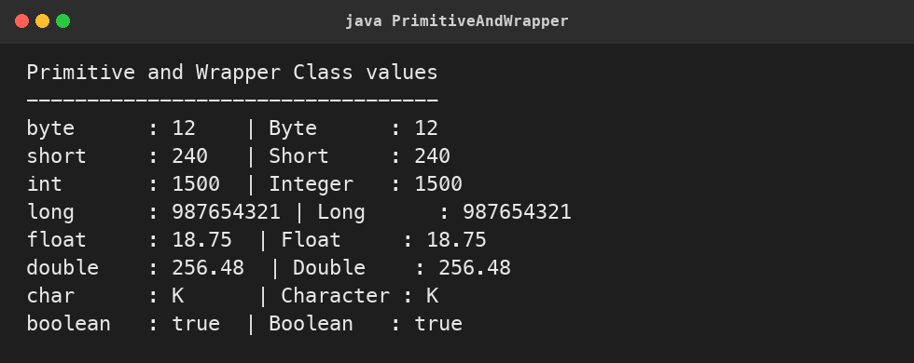
Program 2: Autoboxing Demonstration
Primitive int, double, char, and boolean values are assigned to Integer, Double, Character, and Boolean. Java performs autoboxing during the assignment.
public class AutoboxingDemo {
public static void main(String[] args) {
int number = 100;
double marks = 92.5;
char grade = 'A';
boolean passed = true;

Integer numberObject = number;
Double marksObject = marks;
Character gradeObject = grade;
Boolean passedObject = passed;

System.out.println("Autoboxing Demonstration");
System.out.println("------------------------");
System.out.println("int " + number + " -> Integer : " + numberObject);
System.out.println("double " + marks + " -> Double : " + marksObject);
System.out.println("char " + grade + " -> Character : " + gradeObject);
System.out.println("boolean " + passed + " -> Boolean : " + passedObject);
}
}
Output of Program 2
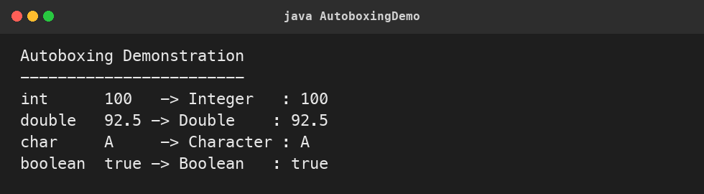
Program 3: Unboxing Demonstration
Integer, Double, Character, and Boolean objects are assigned to int, double, char, and boolean variables. Java performs unboxing and the primitive values are printed.
public class UnboxingDemo {
public static void main(String[] args) {
Integer numberObject = Integer.valueOf(250);
Double priceObject = Double.valueOf(49.99);
Character letterObject = Character.valueOf('M');
Boolean statusObject = Boolean.valueOf(false);

int number = numberObject;
double price = priceObject;
char letter = letterObject;
boolean status = statusObject;

System.out.println("Unboxing Demonstration");
System.out.println("----------------------");
System.out.println("Integer " + numberObject + " -> int : " + number);
System.out.println("Double " + priceObject + " -> double : " + price);
System.out.println("Character " + letterObject + " -> char : " + letter);
System.out.println("Boolean " + statusObject + " -> boolean : " + status);
}
}
Output of Program 3
